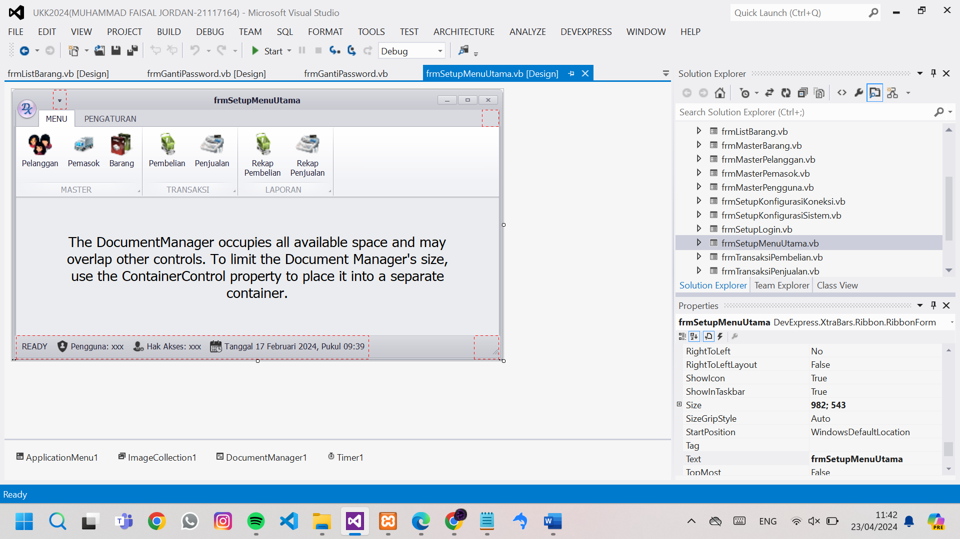

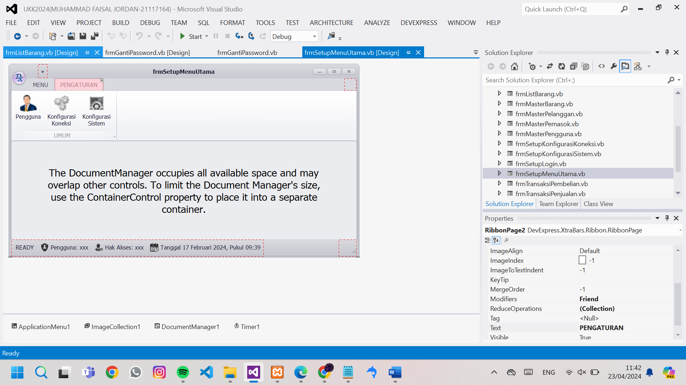

Public Class frmSetupMenuUtama

Private Sub BarButtonItem1_ItemClick(sender As Object, e As DevExpress.XtraBars.ItemClickEventArgs) Handles btnPelanggan.ItemClick

frmMasterPelanggan.MdiParent = Me

frmMasterPelanggan.WindowState = FormWindowState.Maximized

frmMasterPelanggan.Show()

End Sub

Private Sub BarButtonItem2_ItemClick(sender As Object, e As DevExpress.XtraBars.ItemClickEventArgs) Handles btnPemasok.ItemClick

frmMasterPemasok.MdiParent = Me

frmMasterPemasok.WindowState = FormWindowState.Maximized

frmMasterPemasok.Show()

End Sub

Private Sub BarButtonItem3_ItemClick(sender As Object, e As DevExpress.XtraBars.ItemClickEventArgs) Handles btnBarang.ItemClick

frmMasterBarang.MdiParent = Me

frmMasterBarang.WindowState = FormWindowState.Maximized

frmMasterBarang.Show()

End Sub

Private Sub frmSetupMenuUtama_Load(sender As Object, e As EventArgs) Handles Me.Load

BarButtonItem5.Caption = "pengguna: " & My.Settings.lgnNama()

BarButtonItem6.Caption = "Hak Akses: " & My.Settings.lgnAkses()

Try

Me.BackgroundImageLayout = ImageLayout.Stretch

Me.BackgroundImage = Image.FromFile(My.Settings.LokasiWallpaper)

Catch ex As Exception

End Try

End Sub

Private Sub Timer1_Tick(sender As Object, e As EventArgs) Handles Timer1.Tick

Dim Tgl = Now

BarButtonItem7.Caption = "Tanggal " & Format(Tgl, "dd MMMM yyyy") & " ,Pukul " & Format(Tgl, "HH:mm:ss") & ""

End Sub

Private Sub BarButtonItem11_ItemClick(sender As Object, e As DevExpress.XtraBars.ItemClickEventArgs) Handles btnPembelian.ItemClick

frmTransaksiPembelian.MdiParent = Me

frmTransaksiPembelian.WindowState = FormWindowState.Maximized

frmTransaksiPembelian.Show()

End Sub

Private Sub BarButtonItem12_ItemClick(sender As Object, e As DevExpress.XtraBars.ItemClickEventArgs) Handles btnPenjualan.ItemClick

frmTransaksiPenjualan.MdiParent = Me

frmTransaksiPenjualan.WindowState = FormWindowState.Maximized

frmTransaksiPenjualan.Show()

End Sub

Private Sub BarButtonItem13_ItemClick(sender As Object, e As DevExpress.XtraBars.ItemClickEventArgs) Handles btnRekapPembelian.ItemClick

frmLaporanPembelian.MdiParent = Me

frmLaporanPembelian.WindowState = FormWindowState.Maximized

frmLaporanPembelian.Show()

End Sub

Private Sub BarButtonItem14_ItemClick(sender As Object, e As DevExpress.XtraBars.ItemClickEventArgs) Handles btnRekapPenjualan.ItemClick

frmLaporanPenjualan.MdiParent = Me

frmLaporanPenjualan.WindowState = FormWindowState.Maximized

frmLaporanPenjualan.Show()

End Sub

Private Sub BarButtonItem15_ItemClick(sender As Object, e As DevExpress.XtraBars.ItemClickEventArgs) Handles btnPengguna.ItemClick

frmMasterPengguna.MdiParent = Me

frmMasterPengguna.WindowState = FormWindowState.Maximized

frmMasterPengguna.Show()

End Sub

Private Sub BarButtonItem16_ItemClick(sender As Object, e As DevExpress.XtraBars.ItemClickEventArgs) Handles btnKonfigurasiKoneksi.ItemClick

frmSetupKonfigurasiKoneksi.ShowDialog()

End Sub

Private Sub BarButtonItem17_ItemClick(sender As Object, e As DevExpress.XtraBars.ItemClickEventArgs) Handles btnKonfigurasiSistem.ItemClick

frmSetupKonfigurasiSistem.ShowDialog()

End Sub

Private Sub RibbonControl_Click(sender As Object, e As EventArgs) Handles RibbonControl.Click

End Sub

Private Sub BarButtonItem9_ItemClick(sender As Object, e As DevExpress.XtraBars.ItemClickEventArgs) Handles BarButtonItem9.ItemClick

If MessageBox.Show("akses aplikasi akan di tutup. lanjutkan?", "Validasi", MessageBoxButtons.YesNo, MessageBoxIcon.Question) = Windows.Forms.DialogResult.Yes Then

frmSetupLogin.Show()

Me.Close()

End If

End Sub

Private Sub BarButtonItem10_ItemClick(sender As Object, e As DevExpress.XtraBars.ItemClickEventArgs) Handles BarButtonItem10.ItemClick

If MessageBox.Show("akses aplikasi akan di tutup. lanjutkan?", "Validasi", MessageBoxButtons.YesNo, MessageBoxIcon.Question) = Windows.Forms.DialogResult.Yes Then

Application.Exit()

End If

End Sub

Private Sub BarButtonItem8_ItemClick(sender As Object, e As DevExpress.XtraBars.ItemClickEventArgs) Handles BarButtonItem8.ItemClick

frmGantiPassword.showdialog()

End Sub

End Class